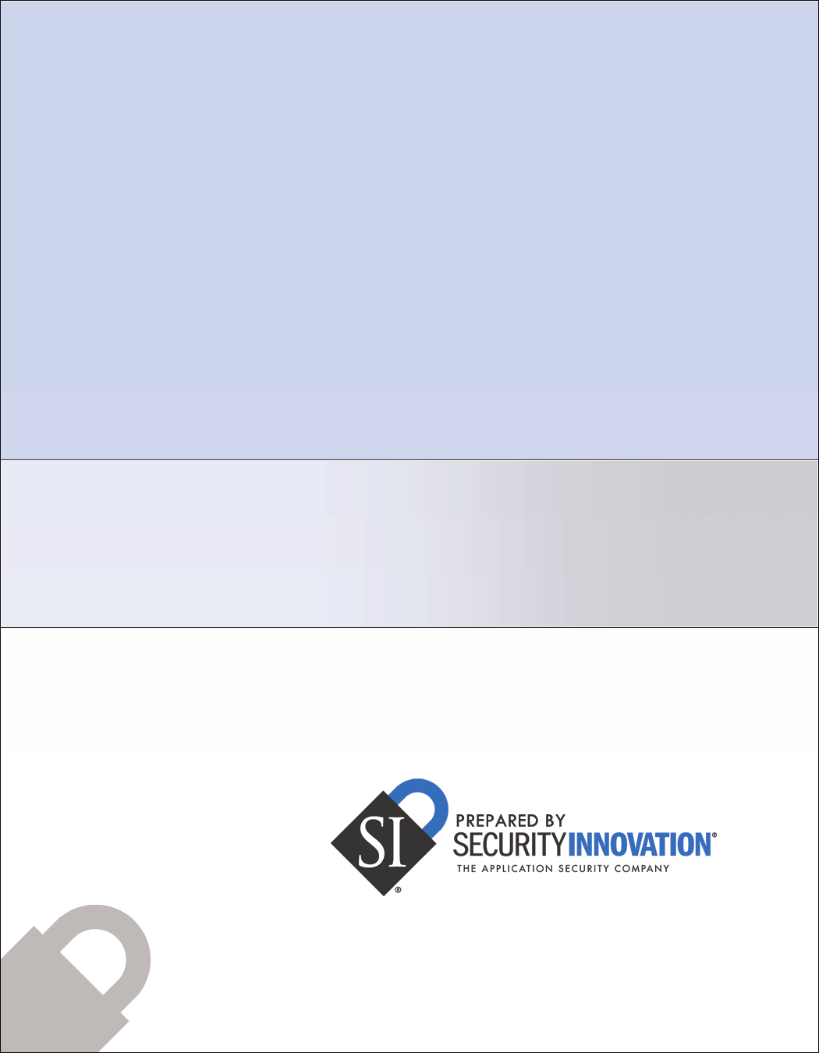

.NET Framework Installation Impact Methodology

Assessing the impact of installing the .NET Framework on Windows systems

Security Innovation, Inc.
187 Ballardvale Street, Suite A260
Wilmington, MA 10887
+1.978.594.1008
www.securityinnovation.com
February 2005

Table of Contents

1.0 Executive Summary 3
2.0 Introduction 5
3.0 Security Assessment of the .NET Framework 8
4.0 Performance Assessment of the .NET Framework 15
6.0 Step-by-step 19

1.0 Executive Summary
The .NET platform is an execution environment developed by Microsoft to enable a richer, more robust setting for applications. The traditional method of developing applications in a programming language such as C++ and then compiling to machine, or native code, is replaced by the notion of Managed Code. This is an intermediate environment that interprets and executes the application at runtime. It provides a number of security benefits including:
- Alleviation from memory management - The Framework now handles all types of operations such as memory allocations and deallocations. No longer are programmers required to use direct memory pointers. This reduces the prevalence of certain types of security issues, such as buffer overruns and format string vulnerabilities.
- Tighter security control over applications - Permissions given to running code can be scoped more granularly. Rather than specify privileges at the process level, each block of code can have its own permissions. This allows applications to run with restricted privileges except when they are performing actions that specifically require higher privileges. Code can be signed and placed in different categories of runtime privilege based on source. This enables mobile code to run in a more restricted environment than trusted code.

The .NET Framework offers a rich Application Programming Interface (API): Rather than reinvent the wheel, application programmers can use existing class libraries with components that have been previously developed and tested. This greatly facilitates the development process, significantly reducing the time to market, as well as the potential of faults in code.

Microsoft bundles the .NET Framework along with the newer versions of its Windows operating system and makes it freely available as a separate download. The .NET Framework is also expected to become a major component in Microsoft’s future operating systems. The migration towards runtime environment based applications is fast becoming a trend. Sun Microsystems’Java technology is another major contender

Some concerns, however, have been raised as to the possible adverse effects of the installation of the .NET Framework on Windows-based systems. Such effects may manifest themselves in negative impacts to system security, performance, and stability. The goal of this analysis is to investigate these concerns, and measure what effects the Framework has on its host systems.

1.1 Scope of Analysis
This study investigates the impact of installing the .NET Framework on target Windows machines. We measure what effects the installation has on the system as a whole. Specifically, we focus on three areas of concern:
- Security - A primary concern is the impact on the security of the operating system. With the abundance of Internet attacks, such as hacking, viruses and Trojans, special consideration must be taken to ensure that the installation of a major code base on the system does not in any way jeopardize or impair its level of security.

- Performance - Another major issue is the speed and efficiency with which a system operates. The .NET Framework is a rich runtime environment and, as such, may incur overhead that has an negative impact on other processes on the system. We measure the performance impact associated with the installation, and quantify the delta between a vanilla system, and a .NET-enabled system.

- Stability - The addition of any software to a system can impact reliabilty and robustness. This is of particular concern with the use of the .NET Framework since it impacts how all Windows application start execution. We investigate whether the installation of the Framework measurably changes the stability of the system in any way.

Security Innovation has been commissioned and funded by Microsoft to define a methodology that would evaluate the above aspects of the installation of the .NET Framework. We’ve endeavored to identify objective measures to enable a meaningful, independent and unbiased evaluation of the installation. The methodology described below can be used to generate repeatable, verifiable and unbiased results.

1.2 Future Areas of Research
The .NET Framework is a complex system, with many aspects not covered by this analysis. First and foremost is its effect on the system when applications (assemblies) execute in its context. The aspects we measure, mentioned above, would greatly vary under the execution constraints of applications, with a variance as great as the range of applications that the Framework supports. This could be a fertile ground for much future research, but is out of the scope in this particular analysis.

2.0 Introduction
The purpose of this study is to investigate concerns that the .NET Framework, once installed, may have a negative impact on system security, stability and performance. This methodology document describes the quantitative measurements that will be made in each of these areas. This methodology provides a general look at the security, stability and performance impact of installing the Microsoft .NET Framework on Windows workstations and servers:

- Security – How is the system affected by the installation of the .NET Framework? What changes are made to the machine? How do these changes affect the overall security stance of the system? Are any new avenues of attack exposed by the Framework? If security is negatively impacted, can it be mitigated?

- Performance – Is system performance adversely affected by the installation of the .NET Framework? Measuring such parameters as RAM, free disk space, and CPU utilization, just what aspects of performance, if any, are impaired by the Framework? If performance issues indeed arise, can they be mitigated?

- Stability – Is system stability adversely affected by the .NET Framework installation? Are core components and DLLs in the system added or replaced? How are existing applications affected, if at all, by the installation?

Systems Measured
We measure security, performance, and stability impact on three operating system configurations. We’ve picked two recent Windows operating systems and then added one configuration to study the impact of adding a managed service to the system:
- Windows XP SP2 Pro
  - As installed from the official CD by Microsoft
  - Install all patches from Windows Update (up to and including the date of writing, 2/16/2006)

- Windows 2000 SP4 Workstation
  - As installed from the official CD by Microsoft
  - Install all patches from Windows Update (up to and including the date of writing, 2/16/2006)

- Windows XP SP2 Pro (with an ATI card that has a .NET control panel applet)
  - Same as configuration (1), but with the Catalyst 6.2 by ATI.
  - This software is publicly available for download on the Internet, and will provide some measure of impact when running a .NET service

On each operating system configuration, we installed the following versions of the .NET Framework:
- .NET Framework 1.1 SP1
  - Available as Microsoft .NET Framework Version 1.1 Redistributable Package from the Microsoft download site
  - Published 3/30/2004
  - Download size is 23.1 MB.

- . NET Framework 2.0
  - Available as “Microsoft .NET Framework Version 2.0 Redistributable Package (x86)” from the Microsoft download site
  - Published 1/22/2006
  - Download size is 22.4 MB.

- .NET Framework 2.0 and .NET Framework 1.1 SP1 (side by side)
  - Combining (I) and (II) above, by installing them in succession.

This results in nine unique configurations for analysis. For each configuration we will make a measurement before the Framework is installed to generate a baseline, and then again after the install to see the delta. All before and after measurements for each configuration are tested on identical hardware configurations. This ensures that the measurements are accurate and provide a meaningful delta of .NET Framework’s impact.

For performance measurements, we further define two measurement scenarios:
- Steady State - This state is meant to simulate an idle system, with no processes except for system default processes. The system is booted from scratch. It is then left alone for 60 seconds to allow background services to start up. Then a user login is performed. Once the desktop environment is set up, measurements begin.
- Typical - This state is meant to simulate a lightly loaded system, with a minimal number of applications executing concurrently. The applications chosen are listed in section 4.0

The hardware configuration used in our measurements is an AMD 32-bit, Athlon 2600 Processor with 512MB of RAM and an ATI Radeon Display Adapter..

This study inspects the configurations described above. The results are then analyzed and any potential concerns noted. In the case where such concerns suggest a significant impact in any of the fields of study, we discuss potential ways to mitigate the impact and improve the system.

Out of Scope
This methodology document describes a repeatable mechanism for measuring the security, performance and stability impact of installing the .NET Framework on a pre-existing system. The focus is on overall system impact not the impact of running specific managed applications. There are other related aspects of the Framework that may impact the security, performance and stability of managed applications. The following points are considered beyond the scope of this study:

- Specific .NET applications - The .NET Framework is just that – an execution framework for applications. Specific applications may contain specific faults. This study concerns itself only with the effects of the Framework installation itself.

- Potential software faults within the Framework - The Framework itself could contain software faults that would negatively impact applications written against it. This study focuses solely on the installation of the Framework, and does not concern itself with run-time flaws in the Framework itself.

- Full assessment of the stability impact of the .NET Framework Installation - The assessment of the potential impact of the Framework installation we conduct here is limited in scope, focusing on a study of files and dependencies only. We use the result of our investigation into file and dependency changes to extrapolate potential system stability impact. Taking into account specific application configurations and/or runtime scenarios is beyond the scope of this analysis.

3.0 Security Assessment of the .NET Framework
This section introduces and defines the security aspects of the .NET Framework that will be measured. First, we present the goals of the study (from the security perspective), then we introduce the techniques used for measurement.

3.1 Goals
This study measures potential attack vectors introduced by the installation of the .NET Framework. The goal of this measurement is to answer the following question:

Does the installation of the .NET Framework on an existing system change its susceptibility to malicious attack?

In order to measure a change in susceptibility to attack, one must first attempt to assess and measure the avenues of attack. This is hardly trivial as one must consider all possible theoretical attacks whether or not they would prove successful. In other words, we are interested in the feasibility of an attack, without regard to its potential success or failure.

Therefore, we use the concept of an “attack surface.” Microsoft’s definition is:

“The attack surface of an app is the union of code, interfaces, services, protocols, and practices available to all users, with a strong focus on what is accessible to unauthenticated users”

The definition of an attack surface takes into account the following factors:
- Interfaces - Any channel of input that may be controlled by a user or an attacker. Interfaces may consist of direct user input or input from other sources such as files, registry, databases, or external components.
- Code - Any code path that may be executed by the user or an attacker may result, under the wrong use case, in an attack vector.
- Protocols - Inter-component communication and/or network protocols may hold weaknesses – especially if proprietary protocols are involved.
- Users - The more users a system has, the more potential avenues of an attack exist in username/password combinations. An attacker need only guess one valid combination to obtain access.
- Network Ports - Open TCP/IP ports are entry points into application, and provide more potential code paths that attackers have at their disposal. TCP/IP ports pose a greater risk due to their high accessibility. Unless a firewall solution is used, any attacker with Internet connectivity to the system may attempt to exploit them.

The underlying philosophy is that “less is more” – i.e. fewer code/interfaces, etc) provide for better security. Each interface or code path that is available to a low-privileged or unauthenticated user may be used as a fulcrum for an attack. Additional code paths often introduce unintended functionality (as a result of unhandled use cases, potential logic faults, etc). It is exactly this unintended functionality that an attacker will attempt to exploit.

3.2 Method of Measurement
In order to properly quantify any change in attack surface, a consistent metric must be introduced. The metric must be a well documented and accepted scoring system that provides as accurate a measurement of the attack surface as possible, in order to conduct a comparison.

The metric chosen for this study is the Relative Attack Surface Quotient, (RASQ). This metric, defined by Microsoft, has become a widely accepted assessment for system attack surface. It has been validated in an independent study by Ernst & Young, and has been successfully applied in non-Microsoft operating systems such as Linux.

RASQ is a metric for measuring the attack surface of a given software application/platform. It uses a table of items with known risk to construct a raw score. Each metric is modified with a bias value that is calculated based upon relative risk. Once bias has been applied, a final RASQ score is calculated that gives an indication of the system’s attack surface. A single RASQ score is not a useful measure. However, comparing RASQ scores across systems can give a quantitative measure of relative risk. We used RASQ measurements before and after installing the .NET Framework to determine the impact of the install on overall system attack surface.

It is important to emphasize that a high RASQ rating does not necessarily imply the existence of faults. It does, however, suggest that an attacker has more avenues of an attack against this system, as compared to a system with a lower rating.

RASQ was chosen due its widespread acceptance and prior validation by third parties. In addition, there exist well documented studies of many systems using this metric. This study measures how installing the .NET Framework impacts a system’s RASQ score.

The following figure shows a sample of RASQ ratings for the Windows environments, as measured by Microsoft:
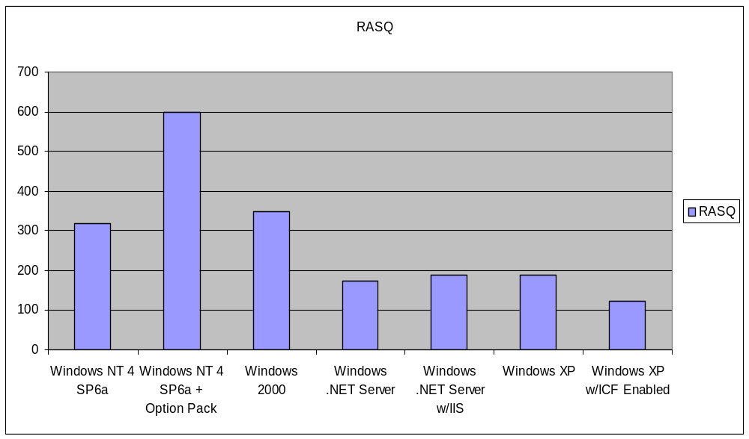

Source: Michael Howard, Microsoft, http://www.cigital.com/ssw/presentations/howard.ppt

The following table lists the parameters used in the RASQ ratings for the Microsoft Windows environments.

Since some vectors pose more potential risk than others, RASQ defines a “bias” value for each. This makes the RASQ metric a weighted sum of its vectors. For example, in the table below, each installed service is biased by a factor of 0.2, whereas SYSTEM services (i.e. privileged code) are biased by a factor of 0.9 – implying the latter are far more of a potential risk than the former.

Note: Some of the vectors in the table below may show no change when the .NET Framework is installed. Regardless, the study evaluates all vectors in order to provide a complete picture of Framework’s impact.

Attack Vector | Description | Bias
Open sockets | TCP and UDP ports that are open by applications in the operating system. Each open port is an entry point into an application. To further exacerbate the situation, unless ports are protected (filtered), such access can be carried out remotely. | 1.0
Open RPC endpoints | Remote Procedure Call and COM interfaces in use. RPC endpoints are multiplexed over very specific TCP/IP ports (commonly 135, 139 and 445), and enable direct invocation of application components. | 0.9
Open named pipes | A special case of RPC endpoints, accessible over TCP port 139 with a dedicated namespace (\\SERVER\PIPE\...) | 0.5
Services | Services are system processes executing whether or not users are actively logging on the system. Services handle such tasks as scheduling, resource access, and others. Services are, in effect, code paths that may be targeted by an attacker. | 0.2
Services running by default | System processes (see above) with a startup mode of “automatic,” that execute every time the system is started. | 0.8
Services running as SYSTEM | Any system processes that execute under the privileges of local system, and/or local administrator. These services are especially attractive from an attacker’s point of view, as their code enjoys privileges and full access to the system. | 0.9
Active Web handlers | Internet Information Server Active Web Handlers generate specific content by invoking special applications. They are considered applications, and, due to the potential of their remote invocation, are an attack vector. | 1.0
Active ISAPI Filters | Internet Information Server API Filters are scripting engines and other applications that are executed by IIS for a given MIME type or file extension. These ISAPI filters are, in effect, applications, and, as they are executed remotely, may contain faults. | 1.0
Dynamic Web pages | Dynamic Web pages contain scripts (VBScript or other) to generate dynamic content, based on user input. As such, they are effectively applications, and, because they are executed remotely, may contain faults. | 0.6
Executable vdirs | Virtual Directories under IIS that allow the remote execution of programs within them. Unlike static content directories, such directories may contain vulnerable programs that will be exploited by attackers. | 1.0
Enabled Accounts | Any user accounts that may login, in any form – interactive, network or batch. The more user accounts are enabled the more potential avenues of attack an attacker has, e.g. by guessing a user password. | 0.7
Enabled Accounts in admin group | Any user accounts defined to be part of the Administrator’s group. Such accounts, if compromised, lead to the full compromise of the system. | 0.9
Null Sessions to pipes and shares | Server Message Block “NULL Sessions” enable an attacker to enumerate pipes, shares, and potentially users, by connecting to a remote machine, yet not supplying any credentials whatsoever – not even those of a guest. | 0.9
Guest account enabled | The Guest account is defined by default, but should not be enabled. It would enable an attacker to access resources as a restricted but authenticated user, without having to supply a password or proof of identity. | 0.9
Weak ACLs in FS | NTFS permissions (access control lists) set by default on the local filesystem during installations. Specifically, such insecure defaults as “Everyone: Full Control”, essentially disabling file system security. | 0.2
Weak ACLs in Registry | Registry key permissions set by default on various keys, specifically HKEY_LOCAL_MACHINE and HKEY_USERS. Insecure permissions may allow local attackers to modify registry values and modify the system configuration to become less secure. | 0.4
Weak ACLs on shares | Network shares of filesystem resources may, if not properly protected, be used as an attack vector to introduce various threats into the filesystem – such as Trojans and viruses. Shares may also leak information by making sensitive data publicly accessible. | 0.9
ActiveX | ActiveX controls registered on the system. ActiveX controls are a mechanism for the execution of mobile code through web pages. The more registered ActiveX controls a system has, the more potential for faults. | 0.6

Note: The Bias values used are in accordance with the ones set by Microsoft and later re-evaluated by Ernst & Young. The official RASQ measurements by Microsoft also take into account Jscript and VBScript technologies. We, however, leave them out of scope as we feel they cannot be properly measured, and would not be affected by installation of the .NET platform.

3.3 Measurement Tools
In order to properly measure the RASQ, we employed specific tools listed in the table below:

Tool | Location | Description
FileMon v7.02 | http://www.sysinternals.com/ Utilities/Filemon.html | View and monitor file system activity in real time
NMap 4.01 | http://www.insecure.org/nmap/ | Open source port mapper
RegMon v7.02 | http://www.sysinternals.com/ Utilities/Regmon.html | View and monitor registry activity in real time
TCPView 2.4 | http://www.sysinternals.com/ Utilities/TcpView.html | Enhanced version of Netstat that shows detailed listing of all open TCP and UDP ports
WinFingerPrint 0.5.14 | http://sourceforge.net/projects/ winfingerprint/ | Winfingerprint is a Win32 MFC VC++ .NET based security tool that is able to determine OS, enumerate users, groups, shares, SIDs, transports, sessions, services, service pack and hotfix level, date and time, disks, and open tcp and udp ports.
OCX Survey | Security Innovation internal application | Lists installed activeX controls including whether they are Scriptable, Safe For Scripting, and Safe For Initialization
Compmgmt.msc | Installs with Windows | Computer Management MMC Snap-In
Services.msc | Installs with Windows | Services Control Panel (MMC Snap-In)
Cacls.exe | Installs with Windows | Command line NTFS access control list utility

The following table illustrates the mapping of the Tools to the RASQ vector measurements:

Attack Vector | Tool
Open sockets | NMap - For external port scanning (from outside the machines)  TCPView - To display port list internally. This will uncover any loopback ports, as well
Open RPC endpoints | WinFingerPrint
Open named pipes | WinFingerPrint
Services | Services.msc
Services running by default | Services.msc  WinFingerPrint
Services running as SYSTEM | Services.msc
Active Web handlers | Compmgt.msc
Active ISAPI Filters | Compmgt.msc
Dynamic Web pages | Compmgt.msc
Executable vdirs | Compmgt.msc
Enabled Accounts | Compmgmt.msc
Enabled Accounts in admin group | Compmgmt.msc
Null Sessions to pipes and shares | WinFingerPrint
Guest account enabled | Compmgmt.msc
Weak ACLs in FS | FileMon - to find the files used by the installation  Cacls - to display NTFS ACLs of these files
Weak ACLs in Registry | RegMon
Weak ACLs on shares | Compmgmt.msc
ActiveX Controls | OCX Survey

4.0 Performance Assessment of the .NET Framework
This section introduces and defines the performance aspects of the .Net Framework that are measured in this study. Performance measurements pose a unique challenge because accuracy depends on hardware and operating circumstances such as running processes and resource access. We present a methodology designed to address these factors, fixing as many of the variable parameters as possible. First, we present the goals of this study from a performance standpoint. Next, we describe the specific measurements we make, as well as the methods employed to gather those measurements.

4.1 Goals
This study will assess any performance impacts which are introduced by the installation of the .NET Framework. With respect to performance, we try to answer the following question:

Does the installation of the .NET Framework on an existing system negatively impact its performance?

The goal is to assess the resource requirements of the Framework, and how they might conflict with other, previously installed software.

Specifically, we measure the following aspects:
- Disk Space - What are the storage requirements for the .NET Framework?
- Memory - What is the average memory utilization on the system both before and after the Framework has been installed? Do memory requirements for native applications change after the Framework has been installed?
- CPU Usage - What is the average CPU utilization on the system both before and after the Framework has been installed? Do CPU requirements for native applications change after the Framework has been installed?

4.2 Method
Performance measurements can be dependent upon circumstantial factors. These include:
- CPU - Some software is optimized to very specific processors, processor features (e.g. MMX, SSE), or architecture (32-bit vs. 64-bit).
- Peripheral Hardware - Hardware performance such as disk drives, RAID systems, and network interfaces, will impact system performance.
- Additional Processes - Processes running concurrently on the system may impede performance by introducing bottlenecks and/or other constraints that negatively impact the system as a whole.

4.3 System States
Performance is measured in two system states and during application startup:
- Application Startup - We measure the impact on native application startup. We measure startup time both before and after the .NET Framework has been installed on the following applications: Microsoft Word, Mozilla FireFox, Internet Explorer, and Adobe Acrobat.
- Steady State - This state is meant to simulate an idle system, with no processes except for system default processes. The system is booted from scratch. It is then left alone for 60 seconds (to allow background services to start up). Then, a user login is performed. Once the desktop environment is set up, measurements begin.
- Typical - This state is meant to simulate a lightly loaded system, with a minimal number of applications executing concurrently. The applications chosen are:

Application | Description
Microsoft Word | Start the application, load this methodology document.
Mozilla FireFox | Start the application, load http://www.ebay.com
Internet Explorer | Start the application, load http://www.ebay.com
Adobe Acrobat | Start the application, load this methodology document, in PDF form.

4.4 Measurements
The same measurements are conducted on both system states. The measurements are performed with the following tool:
- Performance Monitor - We will use Perfmon (the built-in tool) to provide and analyze performance graphs. The following counters are looked at:

Measurement | Description
Processor: Privileged Time | % of time spent by CPU in privileged instruction execution mode. This is usually due to servicing of system or API calls. A value tending to “0” is typical in an idle system.
Processor: User Time | % of time spent by CPU in non-privileged instruction execution mode. This is usually due to in memory operations such as modifying variables or register. A value tending to “0” is typical in an idle system.
Disk:Avg. Disk Queue Length | The average number of requests in the disk queue. This value should optimally tend to zero when all requests are serviced in time and no bottlenecks exist.
Memory:Pages/Sec | This value measures the number of paging operations that occur every second. A high value usually implies excessive swapfile usage due to insufficient internal memory.
Process counters (all) | I/O, CPU Usage and Memory Usage statistics of the processes added to the system by the .NET Framework Installation.

NT4’s performance monitor (available as part of the Windows Resource Kit) is used as it provides snapshots in intervals smaller than one second.

5.0 Stability assessment of the .NET Framework
This section introduces and defines the stability impacts of the .NET Framework that are analyzed in this study. By “stability” we mean the robustness of the system as a whole following the installation of the .NET Framework. We begin by presenting the goals of this study from a stability standpoint. We then describe the method.

To quantitatively measure impact of .NET Framework installation on system stability would require testing over a long period of time and in stress conditions to determine mean time to failure. Instead, we investigate changes made to the system by the Framework and use this to extrapolate expected impact on native applications already running on the system. As stated in section 2.2, a full stability check of the system is beyond the scope of this study.

5.1 Goals
This study assesses potential stability impacts introduced by the installation of the .NET Framework. With respect to performance, we try to answer the following question:

Does the installation of the .NET Framework on an existing system measurably change its stability? Does the installation of the Framework increase the chance of a system fault, or otherwise impede its availability?

5.2 Method
To assess the stability impact of the .Net Framework installation, we consider the following points:
- File replacement - Are any files replaced by the .Net Framework installation? We pay particular attention to any Dynamic Link Libraries (DLLs). While new versions of DLLs are usually backward compatible with the previous ones, subtle changes in binary or API structure can cause application faults.
- Registry Key modification - Are any existing registry keys and/or values replaced by the installation? Applications that depend on these values may fail as a result.
- Permissions - Are any filesystem or registry object permissions modified in any way? Applications which rely on certain permissions (such as those commonly assigned to “Everyone”) will fail if a more restrictive set of permissions is applied to these objects.
- Process Startup - Are OS code paths for starting new native application processes impacted by the installation of the Framework?

Note - In the case where a file has been replaced, we point out that the replacement occurred, but a binary analysis to determine the exact differences in the two file versions is beyond the scope of this study. In the case of overwritten DLLs, we analyze the import and export tables using common tools such as Visual Studio’s “DumpBin” or “Dependency Walker”.

6.0 Step-by-Step Gathering of the Data
Our goal is to create a methodology that is repeatable, verifiable and which provides meaningful results to decision makers. Below are the steps that can be followed to build your own set of data for analysis.

6.1 Common setup
- All operations are performed as the Local Administrator, or a member of the Local Administrator’s group. Four snapshots are taken prior to the install:
- A snapshot of the system process state, taken by invoking the Task Manager/Process Explorer
- A snapshot of the system Service state, taken by using the Services control panel applet.
- A snapshot of the system shares. This can be done by a simple “net share” command.
- A file system snapshot, taken by generating a recursive directory listing.

These snapshots are referred to collectively as the Pre-Install snapshot.

- The respective .NET Framework installation is downloaded from the Microsoft download site. This, as stated in Section 2.1, is one or both of the following:
- .NET Framework 1.1 SP1 - Available as Microsoft .NET Framework Version 1.1 Redistributable Package from the Microsoft download site Published 3/30/2004. Download size is 23.1 MB.
- .NET Framework 2.0 - Available as Microsoft .NET Framework Version 2.0 Redistributable Package (x86) from the Microsoft download site . Published 1/22/2006. Download size is 22.4 MB.

- Regmon is started with an appropriate filter in order to intercept all of the installer’s registry access calls.
- Values that are replaced, if any, are listed in a special table. Call this table reg_table I.
- Keys and values that are added, if any, are listed in another special table. Call this reg_table II.
- Existing keys that are accessed are monitored for any type of permission modification.

- FileMon is started with an appropriate filter in order to intercept all of the installer’s filesystem calls.
- Files that are replaced, if any, are listed in a special table. Call this table file_table I.
- Files that are added, if any, are listed in another special table. Call this file_table II.
- Existing files that are accessed are monitored for any type of permission modification.

Both tables are used to assess security and stability impacts.

- The installation process ends. The system is rebooted.

- After reboot, the corresponding snapshots are taken. These are referred to, collectively, as the Post-Install Snapshot.

6.2 Security measurements
The RASQ metric is calculated as follows:
- Every new service is evaluated three times as per the RASQ metric:
- As it has been added, it receives a bias of 0.2 (per system services)
- If it is started by default, it receives a bias of 0.8 (default services)
- If it is started as SYSTEM, it receives a bias of 0.9 (System services).
- Every new share is evaluated as per the RASQ metric (i.e. weak ACLs on it receive a bias of 0.9)
- Every file in file_table1 and file_table2 is evaluated regarding permission. The RASQ bias is 0.2.
- Every registry key is evaluated in reg_table1 and reg_table2 is evaluated, as per the RASQ metric (i.e. weak ACLs on it receive a bias of 0.9)
- New user accounts are evaluated similarly.

The resulting metric value can be added to any base system to obtain the system’s RASQ score post installation of the .NET Framework.

6.3 Performance measurements
Performance counters at the system level are measured and averaged over three periods:
- 1 minute (60 measurements)
- 5 minutes (300 measurements)
- 15 minutes (900 measurements)

For process performance evaluation (as in section 4.3) we measure the counters over the entire process lifetime.

Results are further normalized by comparing the “before” and “after” scores in relative percentage. There are no “right” or “expected” scores since these are very hardware dependent. However, we look for a percentage deviation within a given margin of error of up to 10%.

6.4 Stability measurements
For each file in file_table1, study the dependency structure. Attempt to determine what other files or components are using it. If the file is a DLL, use DumpBin to check its export table. If the export tables are not compatible with one another, this suggests a negative impact on stability.

New files (in table2) are not evaluated, as existing applications remain oblivious to their existence.

For each registry key in reg_table1, study the change in value, as well as potential consumers of this value. Use Regmon with a filter on the modified keys. Execute sample applications and check for any access.

Look for changes to native application process-load code path in the operating system. If there is a change evaluate its potential impact to native application and overall system stability.

7.0 Conclusion
When making any major change to a deployed system, it is worthwhile to consider the impact it will have on the security, performance and stability of that system.

The .NET Framework is a large and complex run-time environment, and it is imperative to ask what impact it will have when installed. Measuring this potential impact is neither straightforward nor easy. This methodology describes several mechanisms that can be used to quantify and analyze the impact of the .NET installer on a deployed system. It has been built specifically for this scenario. However, the methodology is general and flexible enough to be adapted to any application or platform installation on a Windows system.

Security Innovation uses the methodology described in this document to conduct a thorough analysis of installing the .NET Framework. Our results show whether the impact requires either mitigation steps, or in the extreme case, avoidance of the .NET Framework in production systems.

https://support.ati.com/ics/support/default.asp?deptID=894&task=knowledge&questionID=640
http://www.microsoft.com/downloads/details.aspx?FamilyID=262d25e3-f589-4842-8157-034d1e7cf3a3&displaylang=en
http://www.microsoft.com/downloads/details.aspx?familyid=0856EACB-4362-4B0D-8EDD-AAB15C5E04F5&displaylang=en
http://www.microsoft.com/windowsserver2003/techinfo/overview/advsec.mspx
Manadhata, Pratyusa & Wing, Jeannette M. Measuring a System’s Attack Surface CMU-CS-04-102. Pittsburgh, PA: School of Computer Science, Carnegie Mellon University, January 2004.
Appendix A (page 8) of http://www.microsoft.com/windowsserver2003/docs/AdvSec.pdf
http://www.microsoft.com/downloads/details.aspx?FamilyID=262d25e3-f589-4842-8157-034d1e7cf3a3&displaylang=en
http://www.microsoft.com/downloads/details.aspx?familyid=0856EACB-4362-4B0D-8EDD-AAB15C5E04F5&displaylang=en

